Renew your Sacred Feminine spirit with our Spring women’sWorkshop
“Awakening the Goddess within”
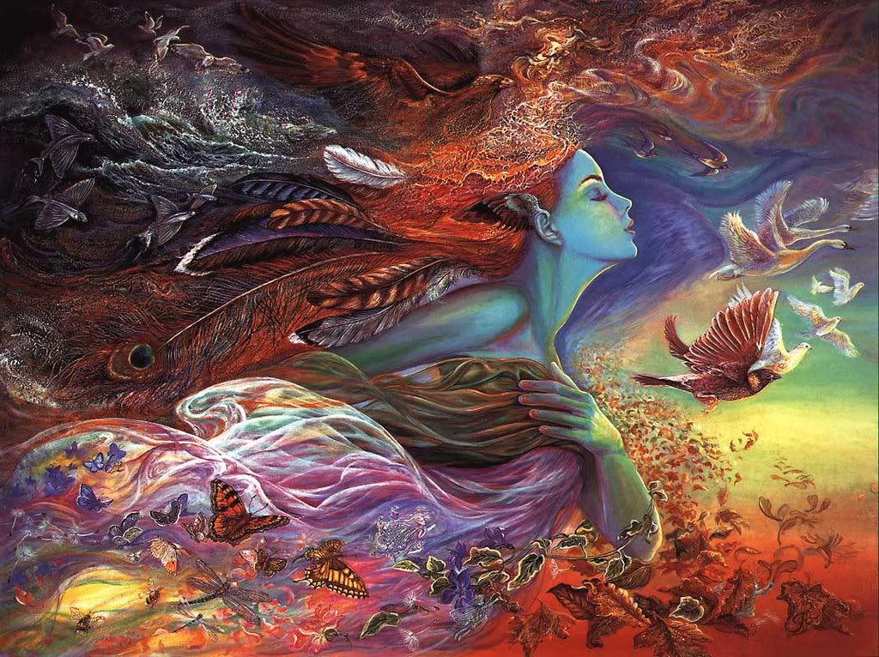
Sunday 6th November, 12-4pm,*$123/$113 *(Includes a tailored bottle of flower essences, afternoon tea and yummy snacks!)
Join us for an empowering afternoon of guided meditation to heal and integrate our energies, rituals to embrace and honour our creative feminine wisdom. Incorporating cleansing yoga poses, breathing practices and acupuncture to release stored tensions and awaken the Spring Goddess within.
Spring provides an opportunity for us to revitalise our energy levels, reinventing the way we perceive ourselves, releasing ways that no longer serve us, creating a new approach that embodies the divine feminine wisdom of our heart and womb. This workshop draws on teachings from Traditional Chinese Medicine, Shamanic & Esoteric practices.
About the facilitator
Angelica Chrisanthi Hristakos is a registered Dr of Chinese Medicine & Acupuncture, mother and a practitioner of Holistic Counseling, Shiatsu and Energetic Medicine. Working in the Health and Wellness field for over 15 years, Angelica has facilitated Women’s workshops for healing, personal growth & transformation at Odyssey House and in her private practice. Her workshops are a holistic, nourishing and empowering way to understand ourselves on a deeper level, recreating our relationship to the divine nature within us.
For bookings: contact Angelica on 0433 080 837 or angelica@therapiesfortransformation.com
www.therapiesfortransformation.com
Location: mien level 3, 370 Queens pd, Clifton Hill

